**CSCE 5400 Formal Languages, Automata, and Computability** - **Fall 2024**

**Name**: Kishan Kumar Zalavadia

**EUID**: 11685261

1. If doable, find a regular expression for the following languages over alphabet {a, b}.
2. Strings with an odd number of **a**

**Ans**: b*a(b*ab*a)*b*

Or

b*ab*(b*ab*ab*)*

1. Both the number of a's and the number of b's are even

**Ans**: (aa + bb + (ab+ba)(aa+bb)*(ab+ba))*

1. No string contains the substring **aa**

**Ans**: (b+ab)*(a+ є)

1. {a**2n** | n є N} U {b**2n+1** | n є N} while N= {0,1,2, 3,...}

**Ans**: (aa)* + b(bb)*

1. Construct a DFA for the following regular expressions :
2. 1*01(0+11)*

**Ans:**

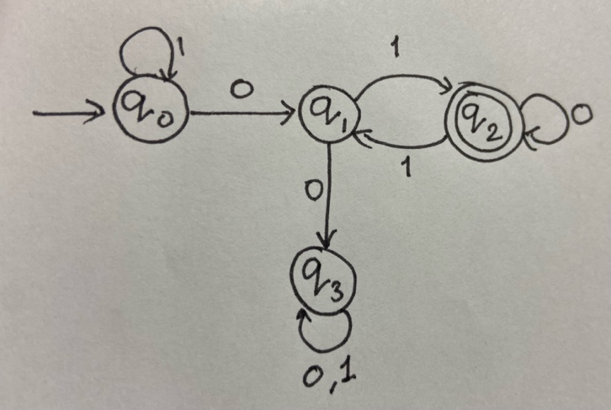

1. ab* + c

**Ans**:

1. ab*+bc*

**Ans**:

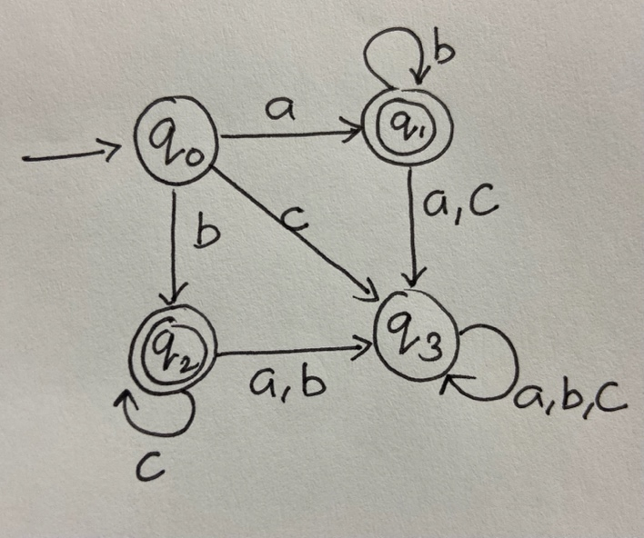

1. b* + b*a(ba)*

**Ans**:

1. Consider the following Finite State Machine,A diagram of a diagram

   Description automatically generated
2. Give an equivalent Regular Expression for the above FSM.

**Ans**: b*a(a+b)*

1. Design an equivalent automaton (DFA) to the above FSM with minimum number of states.

**Ans**:

